Deployment Manual Team Uspark

As a developer the first few things need to be consider while setting up the application. Be patient and try to do deal any errors if you are facing.

1. In your computer first install node version 22 and python version 3.12
   1. Here is the node release guide [Download Here](https://nodejs.org/en/blog/release/v22.11.0) (based on your device compatibility).
   2. Here is Python release guide [Download Here](https://www.python.org/downloads/release/python-3120/) .
2. Install vscode editor. As a team we are using it. If you want to use other editors, it’s up to you.
   1. Here is the VsCode [Download Link](https://code.visualstudio.com/download)
3. Install git into your machine and make sure you have added the path to environmental variables
   1. Here is the Git [Download Link](https://git-scm.com/downloads)
4. Visit <https://github.com/htmw/2025S-RushHour> and follow the red mark instructions.

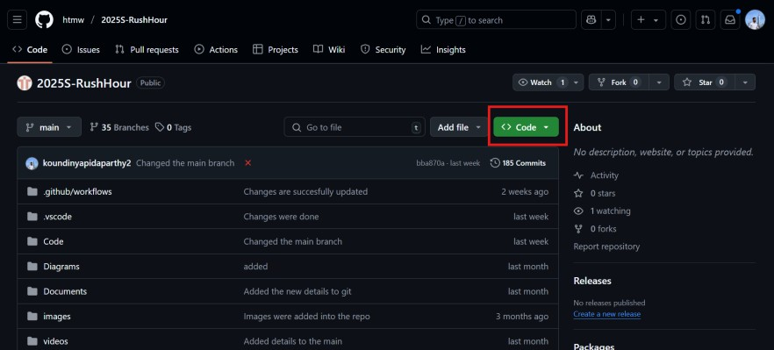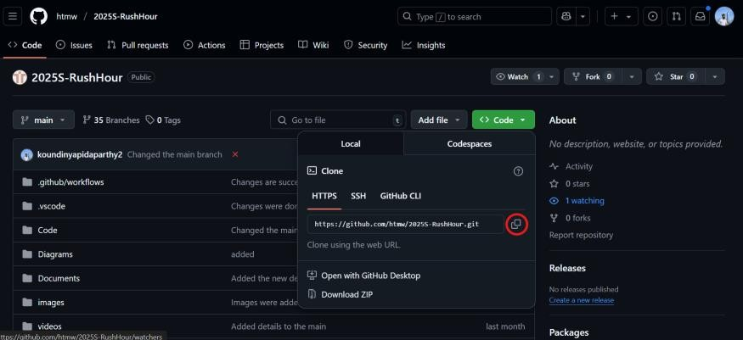

a.

b.

1. Now go to your terminal and follow the commands
   1. To Clone the application we need to use
      1. git clone <https://github.com/htmw/2025S-RushHour.git>
2. And now you will see the entire code base and documentations.

a. 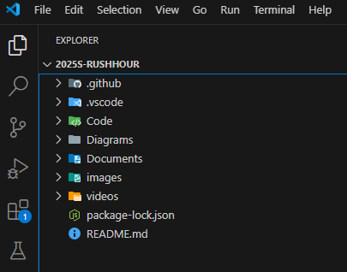

1. To start the application make sure you change the directory into Code and repo you want to work on
2. Lets assume you need to work on all the three repos we need to first change our directory to Code and then uspark-backend.
   1. 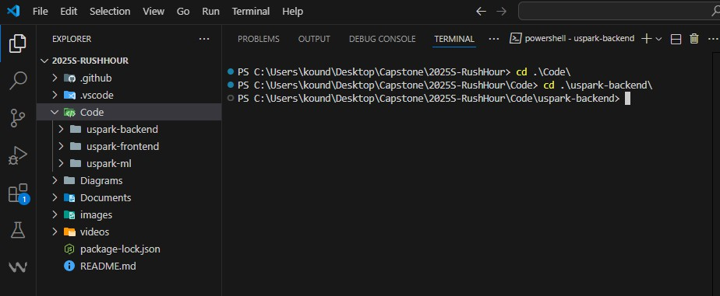
   2. Later we need to install the packages with npm install command and when it was successfully we need to run npm start
   3. 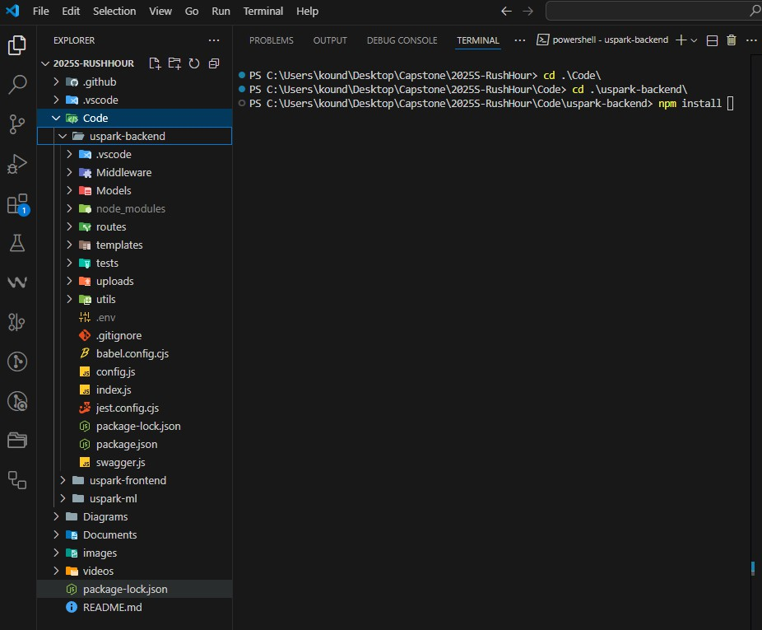
3. Same steps follows with frontend code.
   1. cd code ( change to code directory )
   2. cd uspark-frontend ( change to uspark-frontend directory )
   3. npm Install ( installing packages )
   4. npm start ( starting the packages )
4. With respect to ml setup these steps need to followed
   1. cd code ( change to code directory )
   2. cd uspark-ml ( change to ml directory )
   3. python -m venv venv ( installing virtual environment )
      1. Windows need to run this “venv\Scripts\activate”
      2. macOS/ Linux need to run this “source venv/bin/activate”
   4. And then pip install -r requirements.txt
   5. Then run the command “python app.py”